**Webster Lake Cyanobacteria Investigation: Phase I**

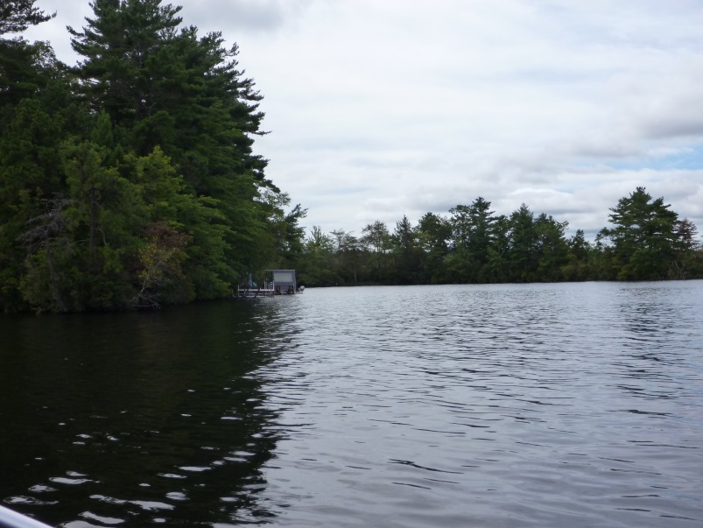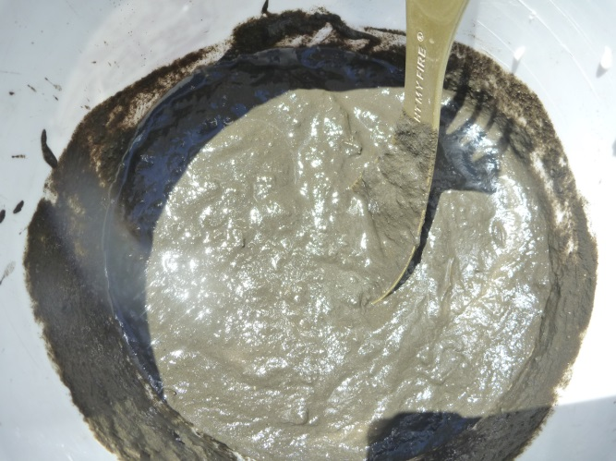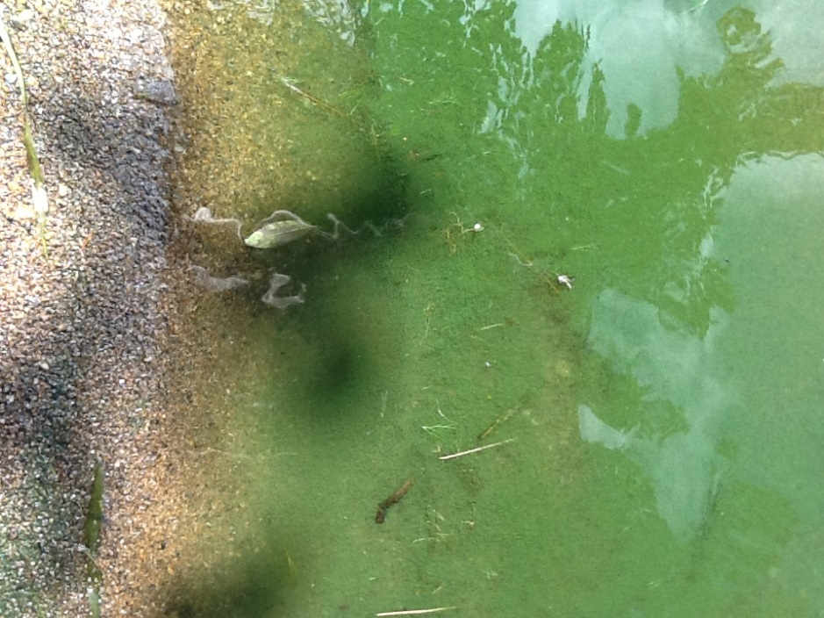

**Prepared by**

**Water Resource Services, Inc.**

**Wilbraham, MA**



**For the**

**Webster Lake Association**

**Webster, MA**

**November 2014**

**Table of Contents**

Introduction 1

Project Approach 1

Results 7

Cyanobacteria Monitoring 7

Storm Water Phosphorus 12

Sediment Phosphorus 15

Discussion 20

Study Findings and Benefits 20

Management Options 21

**List of Tables**

Table 1. Cyanobacteria observation record 8

Table 2. Blue-green algae (Cyanobacteria) in Webster Lake in 2014 10

Table 3. Tributary phosphorus concentrations in volunteer monitoring samples. 13

Table 4. Sediment assessment data for Webster Lake. 16

**List of Figures**

Figure 1. Overview of lake tributary station locations 3

Figure 2. Tributary sampling stations around the northern half of the lake 4

Figure 3. Tributary sampling stations around the southern half of the lake 5

Figure 4. Sediment sampling stations in Webster Lake. 6

Figure 5. *Anabaena lemmermannii*, a bloom forming cyanobacterium 11

Figure 6. Average phosphorus concentration in Webster Lake tributaries in 2014 14

Figure 7. General appearance of surficial bottom sediment in Webster Lake 16

Figure 8. Relation between total and iron-bound phosphorus in Webster Lake. 17

Figure 9. Relation between presence of cyanobacteria blooms and iron-bound phosphorus 18

Figure 10. Comparison of iron-bound phosphorus levels among Webster Lake basins 18

Figure 11. Relation between presence of Asian clams and iron-bound phosphorus 19

# Introduction

Lake Chargoggagoggmanchaugagoggchaubunagungamaugg, more commonly called Webster Lake, is situated just north of the border with Connecticut in central Massachusetts. It covers roughly 1270 acres in three main basins with a highly irregular shoreline and many coves (Figure 1). Maximum water depth is about 45 ft while average depth is about 13 feet. The north basin is the deepest, while the south basin is the shallowest. Webster Lake is very popular for multiple forms of boating, fishing and swimming and much of the shoreline is developed as residential area. The lake is a regional economic engine and a valued natural resource.

The Webster Lake Association has been active in monitoring and managing the lake since at least 2003. Tracking of water quality and rooted plant growths has been conducted. Funds have been expended on watershed management and invasive plant control. More recently, lake users have noticed increases in cyanobacteria (blue-green algae) blooms. Asian clams have also invaded the lake but do not appear evenly distributed. Connections between water quality, sediment features, Asian clams and cyanobacteria have been suggested, and understanding any connections may be helpful in managing to minimize blooms and maximize lake health and utility. A grant was awarded by the Janet Malser Humanities Trust to the Webster Lake Association to evaluate the extent, causes and possible mitigation options for cyanobacteria blooms in Webster Lake.

Work was conducted by the Webster Lake Association (WLA) and Water Resource Services (WRS), acting as a contractor to the WLA. This report represents the conclusion of Phase I, which includes tracking of cyanobacteria in 2014, assessment of storm water inputs to the lake, evaluation of sediment quality in selected areas with and without cyanobacteria blooms, and preliminary assessment of Asian clam distribution. Phase II will look in more detail at the link with Asian clams, follow up on other findings of potential management significance, and will consider more fully the possible management options for cyanobacteria in Webster Lake.

# Project Approach

There were three main elements to Phase I of this project:

1. Convene a meeting of interested parties with experience with Webster Lake to determine the past distribution of cyanobacteria blooms within the lake and related observations on extent, timing, duration and linkage with water quality and weather. Train volunteers to collect algae samples for a more scientific tracking of bloom development in summer 2014. Have samples professionally analyzed to determine if cyanobacteria are present and, if so, which types.
2. Train volunteers to sample storm water for the purpose of gathering data on storm water inputs to Webster Lake. Collect samples before, during and after storms from key runoff conduits (i.e., tributaries, pipes or ditches) and analyze those samples for phosphorus content. Evaluate the differential contribution of phosphorus to parts of the lake from storm water runoff.
3. Sample surficial sediments in areas known to produce cyanobacteria blooms and in other areas not known to be subjected to cyanobacteria blooms. Test those sediment samples for available phosphorus. While collecting sediment samples, a preliminary assessment of the distribution of Asian clams was to be conducted as well.

The meeting to discuss past cyanobacteria blooms in Webster Lake was conducted through arrangements made by the Webster Lake Association, which invited a large number of people to a community hall for a presentation and discussion.

Training for those interested in sampling algae and/or storm water runoff was conducted by WRS, including a presentation at a community hall and a field demonstration session at a small tributary off Lakeside Road, a location that was part of the expected monitoring network. Those planning to collect algae were given a presentation of appearance of blooms and provided with bottles in which suspect algae could be collected. Algae sample bottles are 250 mL polyethylene wide mouth screw top bottles with a label giving instructions and a small vial of glutaraldehyde preservative inside. The vial is removed prior to collecting a sample, water with suspected cyanobacteria is collected in the bottom, the contents of the preservative vial are dumped into the bottle, along with the vial itself, and the bottle is capped and shaken. The label is filled out with the location and date of sample collection. Samples were kept in a dark cooler until picked up for analysis by a trained phycologist. An information sheet to aid with overall bloom description was provided, and participants were encouraged to email reports and pictures to the phycologist immediately after a possible bloom was detected.

For storm water collection, passive storm water samplers were used, allowing installation prior to an expected storm. The passive sampler is set such that any increase in water depth related to storm flows will allow water to enter the sample bottle through a short tube while air leaves the container through a longer tube. Once the sample container fills, presumably during the first flush created by the storm, there is no further interchange with the flowing water. Samples were to be collected if there was any flow at the point of interest during dry weather when the passive sampler was installed. Within 24 hours of the storm, the passive sampler was retrieved and a post-storm sample was to be collected. It was therefore possible that three samples could be collected from a targeted site: a pre-storm (dry weather) sample, a first flush sample obtained with the passive sampler, and a post-storm (wet or dry conditions) representing the tail of the storm hydrograph.

Storm water sampling locations were chosen by residents based on their knowledge of storm flows. Locations of sampling stations are shown in Figure 1, and in greater detail in Figures 2 and 3. Some locations were sampled during as many as four storms in summer 2014.

Sediment sampling was conducted in areas defined by past or 2014 cyanobacteria blooms. An Ekman dredge was used to collect multiple surficial sediment samples that were composited within areas. Five areas not known to have experienced cyanobacteria blooms were identified for reference sediment sampling (Figure 4, stations WS-1 through WS-5), all in the north or middle basin of Webster Lake. Eight areas with known blooms, most in 2014, were delineated (Figure 4, WS-6 through WS-13), and all known bloom sites were in the south basin of Webster Lake. An additional site, at the deepest point in the south basin, was also sampled for comparison.

Figure 1. Overview of lake tributary station locations

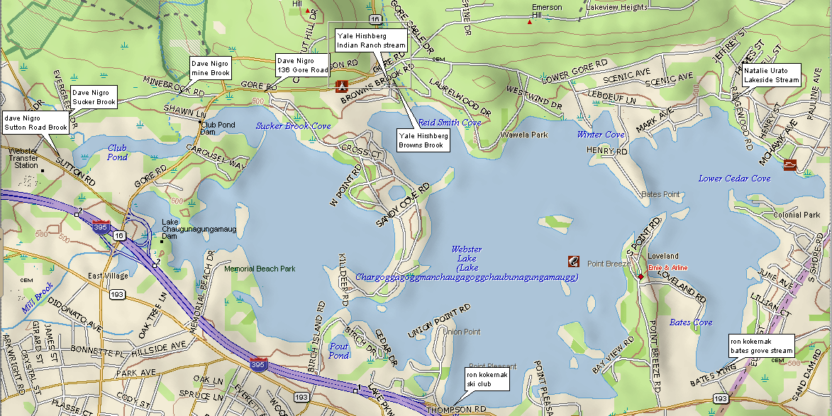

Figure 2. Tributary sampling stations around the northern half of the lake

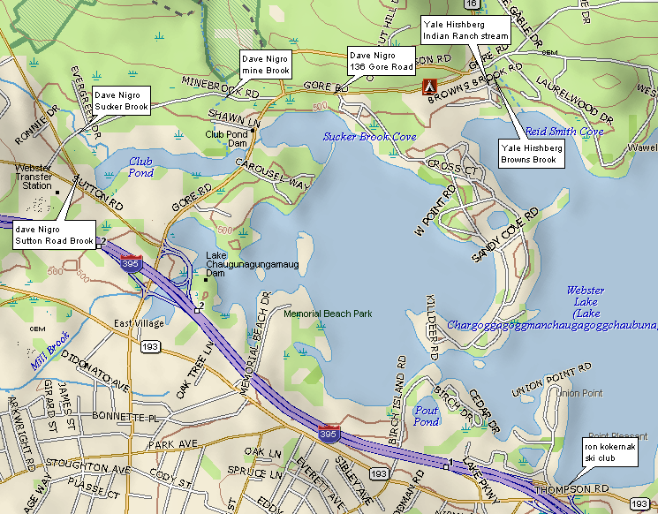

Figure 3. Tributary sampling stations around the southern half of the lake

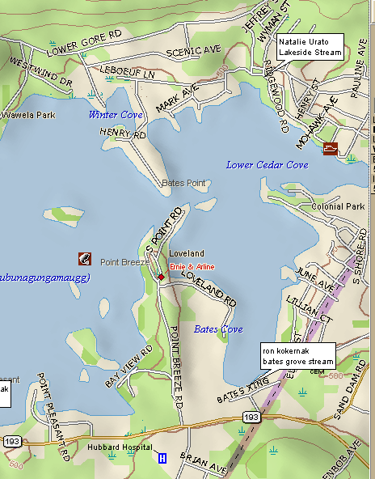

Figure 4. Sediment sampling stations in Webster Lake.

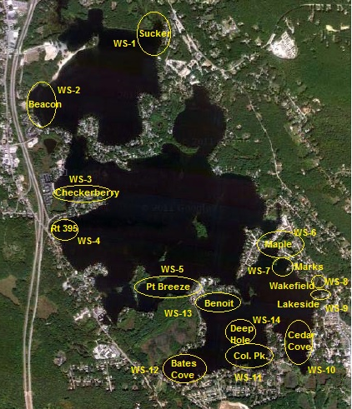

Algae samples were processed by WRS staff. Samples were settled and the center volume was suctioned off to concentrate the sample. Several 0.1 mL aliquots were viewed on an Olympus BX-41 microscope with phase and fluorescence microscopy capability to determine the presence of cyanobacteria.

Water samples were processed by Premier Laboratory of Dayville, CT for total phosphorus by Method EPA 365.1. Samples were delivered within 24 hours of sampling and were preserved to extend holding time if necessary by the laboratory. As total phosphorus involves a digestion process, interconversion of phosphorus among forms was not a particular concern for this study.

Sediment samples were kept cold and in the dark until delivery to Northeast Labs in Meriden, CT. Samples were tested for percent solids, total phosphorus and iron-bound phosphorus according to a standard operating procedure developed by Spectrum Analytical Laboratory of Agawam, MA in cooperation with WRS. The primary focus is on determining how much phosphorus is bound by iron and subject to release under low oxygen conditions. Cyanobacteria appear to be able to utilize this source to grow near the sediment-water interface prior to rising in the water column to form blooms.

# Results

## Cyanobacteria Monitoring

Discussion of past cyanobacteria blooms was inconclusive, as most residents were uncertain about how to recognize blue-green algae and separate them from other types of algae. A major benefit of this project is increased awareness among lake users. Many people noted filamentous growths, often associated with rooted plants, and these are almost always green algae. Some definite cyanobacteria blooms were recognized and cited from the south basin. WRS personnel had noted cyanobacteria blooms during field work in 2012, including growths in several coves off the south basin. WLA members who have attended regional conferences and learned about algae also noted cyanobacteria in the south basin. Some suggestions of cyanobacteria in at least the middle basin were made, but no confirmed reports appear to exist.

Algae monitors provided 100 written reports from 14 separate areas of Webster Lake from late June into September 2014 (Table 1). Only 9 reports, all for south basin locations, clearly identified cyanobacteria. There were 6 possible cyanobacteria reports from the middle basin, but none proved to be cyanobacteria. A total of 12 samples were collected, 9 of which had cyanobacteria in them (Table 2), all from the south basin and all containing *Anabaena lemmermannii* (Figure 5, now called *Dolichospermum lemmermannii*, but we will retain the more familiar *Anabaena* genus for this report). Blooms were found around the periphery of the lake, creating scums and discoloration along shore in early August. Cyanobacteria persisted for about 3 weeks, but the densest accumulations were found in that first week of August. Diatoms, green algae, and some flagellates were also present, but observed cyanobacteria blooms were dominated by the cyanobacterium *A. lemmermannii*. Reports of algae in other areas of Webster Lake were always green filamentous algae or the floating plant duckweed (*Lemna minor*), based on emailed photographs. These were not sampled as per direction of the WRS phycologist.

**Table 1. Cyanobacteria observation record**



**Table 1. (continued) Cyanobacteria observation record**



**Table 2. Blue-green algae (Cyanobacteria) in Webster Lake in 2014**



**Figure 5. *Anabaena lemmermannii*, a bloom forming cyanobacterium**

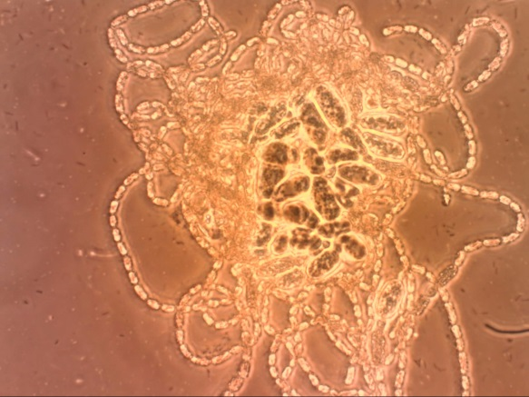

The *Anabaena* bloom occurred suddenly, common for this species, which develops into large colonies of filaments at the sediment-water interface before developing gas vacuoles in cells and floating to the surface. As most nutrient needs were met at the sediment-water interface, cells have adequate phosphorus to allow growth and continued survival for several weeks at the surface, even with low water column concentrations of phosphorus. *Anabaena* has specialized cells that can utilize dissolved nitrogen gas, minimizing the need for nitrate or ammonium in the water column as a source of nitrogen. They are therefore mostly controlled by phosphorus availability and light. When the colonies rise to the surface, they already have resting cells called akinetes in the center of the colony (Figure 5); these cells will drop to the bottom upon death of the colony and germinate later. Germination appears to be related to temperature and light, and usually occurs in late May or June. With normal growth, blooms appear in later June or July, although they can be delayed or skipped depending on weather conditions. Summer 2014 was not as hot or sunny as recent summers, so the early August appearance of the bloom is understandable.

If other cyanobacteria bloom in Webster Lake, there is no evidence from 2014, and there was only one documented bloom in 2014. Previous observations by WRS personnel during a rooted plant survey in 2012 suggest that *Microcystis* and possibly *Aphanizomenon* may have bloomed in the south basin, but this is only from macroscopic examination and is not reliable without microscopic corroboration. Often an initial bloom of one type of cyanobacteria will be followed by other types of cyanobacteria that capitalize on conditions created by the bloom; low carbon dioxide and elevated pH commonly accompany blooms and favor other cyanobacteria. No such follow up blooms were detected in 2014, and this may be a function of weather in that summer. Continued monitoring as part of Phase II seems advisable, as 2014 may not be completely representative of conditions throughout Webster Lake.

## Storm Water Phosphorus

A variety of nutrients control algae growth, but phosphorus is recognized as the most critical nutrient for determining the quantity of algae present. Further, low ratios of nitrogen to phosphorus favor cyanobacteria, so elevated phosphorus inputs are a problem with regard to both the amount and likely types of algae present. Inputs from the watershed have the potential to affect water quality and promote algae growth, with urban and agricultural areas contributing far more phosphorus than forested or other natural areas. The watershed is not particularly large relative to the area of Webster Lake, however, so dilution of inputs is likely to be substantial and concentrations of phosphorus in incoming water will have to be large to make any immediate difference. Dry weather flows from areas dominated by non-point sources (lawns, pastures and other places that require runoff to move contaminants to the lake) of phosphorus tend to have low phosphorus concentrations and do not represent a significant threat. The national average for first flush storm water phosphorus is between 0.3 and 0.4 mg/L, while values >0.02 mg/L can support algae blooms, so the potential exists for storm water to support blooms even with substantial dilution. A focus on storm water is therefore justified.

A total of 51 samples were collected from 9 separate sites over 4 separate storm events in June, July and August of 2014 (Table 3). All but one value was well below the national average and half were below 0.05 mg/L, a generally recognized storm water threshold below which there is no serious concern. Only 16 values exceeded 0.10 mg/L, a level above which many managers become concerned about storm water impacts if flows are more than minor. But most flows are minor in this case, with only two larger tributaries (Mine Brook and Sucker Brook) that exhibited no values >0.10 mg/L. The one very high value was for the unnamed brook at Lakeside Road, which drains into the south basin. This stream was only sampled once, and only the first flush phosphorus value was high, but it was quite high at 0.66 mg/L in June.

Averaging values for multiple storm samples for each station while keeping pre-storm, first flush, and post-storm samples separate, the pattern of values among the sampled stations (Figure 6) illustrates the importance of the first flush samples. Only one pre-storm average and two post-storm averages exhibited values close to the corresponding first flush values (which were mostly very similar). In the cases of the post-storm samples, they were collected relatively close in time to the first flush sample. Where a pre-storm sample is high, consideration of the existence of a point source is warranted. The Bates Grove stream had similar values before, during and after the storm and warrants further investigation. The very high first flush value in the Lakeside stream also warrants further assessment. Otherwise, the storm water values for phosphorus do not indicate serious and imminent threats to water quality in Webster Lake.

The overall acceptability of most storm water inputs is also illustrated by Figure 6. Detention time is more than a year in each basin of Webster Lake, so the inputs of any one storm are not large relative to lake or basin volume. Except for the Lakeside first flush value, the phosphorus concentrations observed are not likely high enough to support cyanobacteria blooms, and no bloom was detected in association with the Lakeside input area.

It has been rare for total phosphorus to be >0.02 mg/L over the last decade of in-lake sampling by the WLA, based on a 2011 review of all available data by WRS. Average phosphorus values in the upper waters of each basin are <0.01 mg/L. This suggests that the water column is not

Table 3. Tributary phosphorus concentrations in volunteer monitoring samples.



**Figure 6. Average phosphorus concentration in Webster Lake tributaries in 2014**



fertile enough to support extensive or extended algae blooms on its own, consistent with the storm water data that show relatively low loading of phosphorus. Yet those inputs add up over time, contributing to the sediment reserves of phosphorus that can be recycled in general and more specifically can be used by cyanobacteria that are ecologically suited to growing near the sediment-water interface. Algae that utilize nutrients derived at the sediment-water interface or in association with “leaky” rooted plants are more likely to dominate in Webster Lake, and that is what we see in the algae reports and samples.

## Sediment Phosphorus

Rock, gravel and sand have minimal available phosphorus in them, but fine particle sediment can harbor large amounts of phosphorus that may be released under certain circumstances. While the edges and shallow water sediment that most people see are very coarse in Webster Lake, much of Webster Lake is underlain by sediment of high organic and low solids content (Figure 7). This sediment tends to have high iron content and phosphorus is attached to much of that iron. This organic sediment exerts considerable oxygen demand, and even though much of the water column has adequate oxygen, levels of oxygen near the sediment surface can get quite low during summer. Under conditions of low oxygen, the iron and phosphorus may dissociate. Loose phosphorus may move into the water column and be available to algae, elevating fertility. Additionally, nitrogen:phosphorus ratios under such conditions tend to be low, favoring cyanobacteria. However, if oxygen is high further up in the water column, iron and phosphorus may recombine and fall out of solution before significant uptake by algae can occur, so there is a delicate balance that governs phosphorus availability that is partly weather dependent and not readily predictable.

Even if it is not moved into the water column, however, the available phosphorus at the sediment-water interface can be used by algae that grow at that interface before floating upward. Filamentous green algae and many cyanobacteria are included in this ecological strategy, and are known from Webster Lake. The bloom forming cyanobacterium found in 2014 invariably grows to a mature colony at the sediment surface before floating upward, and is generally not dependent on water column phosphorus. It is therefore worthwhile to assess the availability of phosphorus in sediment from areas where blooms occur and compare them to conditions in areas where blooms are not found.

Total phosphorus in collected sediment samples (Table 4) ranged from 165 to 1330 mg phosphorus per kg dry weight (mg/kg). This is a generally moderate range for total phosphorus. Iron-bound phosphorus concentrations ranged from 70 to 727 mg/kg, spanning the range from low to high for this sediment feature. There is a weak relationship between total and iron-bound phosphorus in Webster Lake (Figure 8), not enough to use total phosphorus to predict iron-bound phosphorus with any reliability. This is typical in many lakes, as other features of sediment chemistry are important. Other binders of phosphorus are present, including organic matter, calcium and aluminum, and these can vary considerably over space even within a lake, making phosphorus availability difficult to predict based on total phosphorus. One management method, phosphorus inactivation, seeks to move available phosphorus into unavailable forms, lowering availability while leaving total phosphorus unchanged. Iron-bound phosphorus has been found to be the best single predictor of available sediment phosphorus.

**Figure 7. General appearance of surficial bottom sediment in Webster Lake**

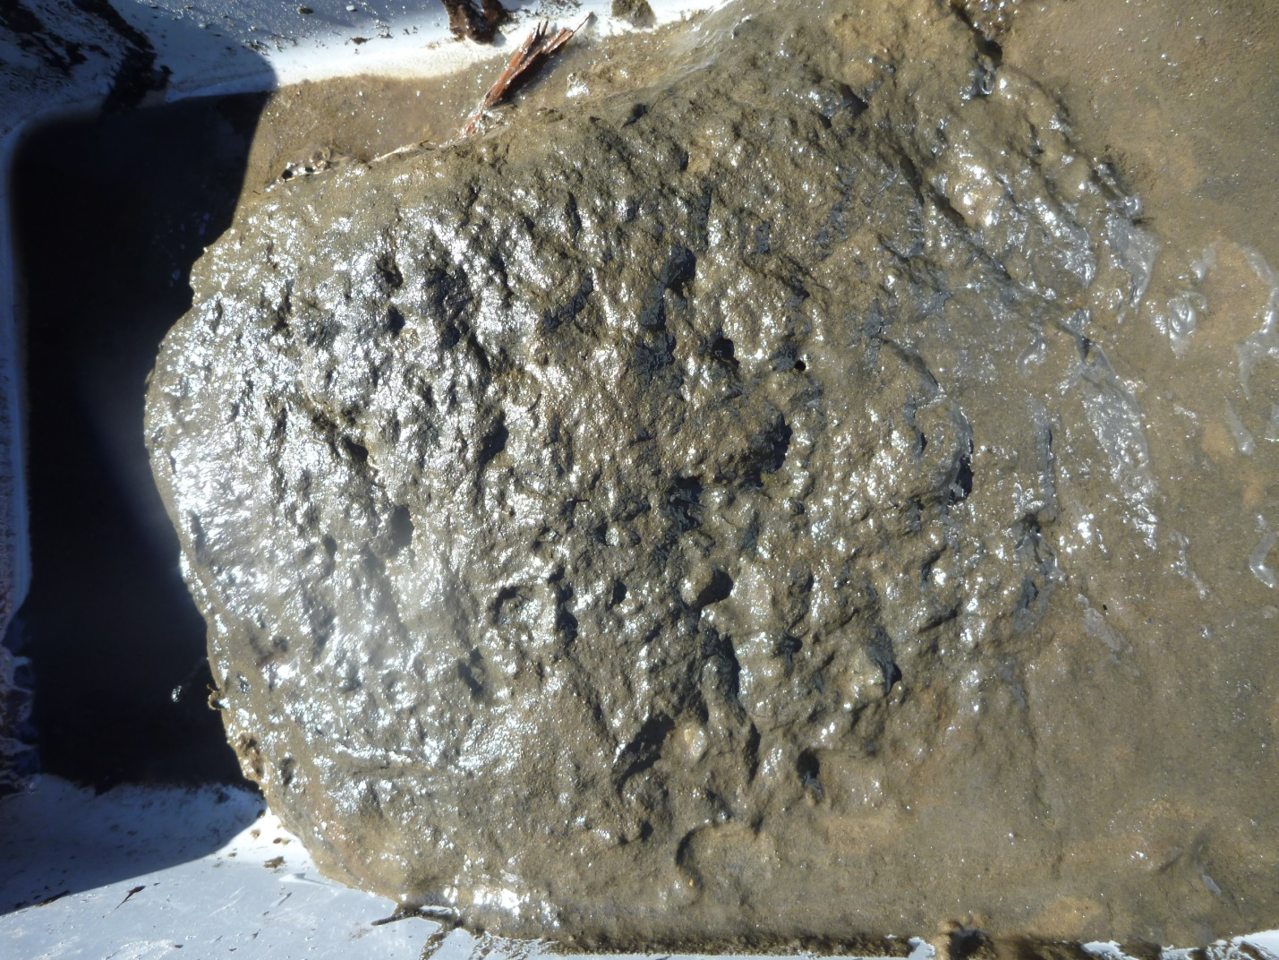

Table 4. Sediment assessment data for Webster Lake.



**Figure 8. Relation between total and iron-bound phosphorus in Webster Lake.**



Iron-bound values <50 mg/kg are generally considered low, while values >500 mg/kg are very high. The iron-bound phosphorus levels in Webster Lake therefore represent a threat of benthic algae support in many areas, although only two values are very high. One key question is whether the pattern of sediment phosphorus availability matches the observed bloom locations. There is no clear relationship, however (Figure 9), with similar values in areas with and without cyanobacteria in 2014 except for one very high value in an area without a cyanobacteria bloom.

One complication is the tendency of buoyant cyanobacteria to move by wind to the shoreline. Virtually all cyanobacteria accumulations noted in 2014 were at the shoreline, but that does not mean that the bloom got its start in those locations. We had hoped that some of the more isolated coves would function as nearly closed systems to provide indications of relationships, but it appears that at least in 2014 the cyanobacteria bloom distribution was a function of where the wind took colonies once they rose to the lake surface.

Assessment of a single deep station in the south basin for comparison purposes yielded the highest total phosphorus value and second highest iron-bound phosphorus level. It may be that cyanobacteria can get their start over much of the area of the south basin, but observable concentrations depend on where the wind blows them. Getting a match between iron-bound phosphorus levels near shore and visible cyanobacteria accumulations may not be especially relevant. Nevertheless, there were enough elevated iron-bound phosphorus levels to suggest very fertile areas for cyanobacteria production (as well as for filamentous green algae, another problem in Webster Lake). Yet the overall level of iron-bound phosphorus is not higher in the south basin than in the other two basins of Webster Lake (Figure 10), so the reason for cyanobacteria blooms in the south basin but not in the north or middle basins remains unknown.

**Figure 9. Relation between presence of cyanobacteria blooms and iron-bound phosphorus**



**Figure 10. Comparison of iron-bound phosphorus levels among Webster Lake basins**



In anticipation of Phase II, the presence of Asian clams was noted in each area where sediment was sampled within Webster Lake. No detailed counts were made; it was a simple measure of presence/absence. Comparison of the presence of Asian clams with the concentration of iron-bound phosphorus (Figure 11) revealed no clear relationship. This does not mean that there is no relationship between Asian clams and cyanobacteria, as the visible cyanobacteria accumulations also did not correlate with iron-bound phosphorus levels. However, comparison of Asian clam presence and cyanobacteria accumulations revealed no obvious correlation. Both Asian clams and cyanobacteria were found at 3 sites, neither was found at 2 sites, cyanobacteria only were found at 2 sites, and Asian clams only were found at 6 sites. It is not yet known if there are more Asian clams in the south basin than in other basins. Asian clam density may have some effect and was not evaluated in this phase of the project.

**Figure 11. Relation between presence of Asian clams and iron-bound phosphorus**



# Discussion

## Study Findings and Benefits

Awareness of algae in general and cyanobacteria in particular was achieved by this project. A large number of lake users, most shoreline or nearby residents, learned about types of algae, what to look for, and how to report information in a scientifically useful format. More attention was paid to lake conditions on a regular basis, and this project represented an educational effort for lake users as well as an effort to advance lake management.

Monitoring in 2014 indicated that cyanobacteria blooms were only present in the south basin of Webster Lake. It is not clear that cyanobacteria blooms do not occur in the other two basins, but the south basin is known to have experienced such blooms in recent years. The blooming cyanobacterium in 2014 was a form of *Anabaena* known to grow at the sediment-water interface to maturity before becoming buoyant and floating to the surface. No other cyanobacteria were abundant in 2014, and the *Anabaena* bloom lasted no more than three weeks in August.

Participants also learned about water sampling and the importance of storm water. Many volunteer monitoring efforts are less effective because they fail to address storm water inputs, the main source of nutrients to most of our lakes today. Point sources, such as sewage treatment or industrial discharges, have been more heavily regulated for several decades and are absent from many lake systems, including Webster Lake. Dry weather inputs tend to be low, as it requires runoff to move contaminants from the land into the lake. Education about the importance of storm water was accomplished by doing this study, and the results are valuable on several levels.

Assessment of nine input points for water from the watershed revealed generally low pre-storm and post-storm phosphorus concentrations. First flush phosphorus concentrations were higher, but only the value at the unnamed stream at Lakeside Road that enters the south basin was truly excessive. Flows were not monitored, but given long detention times in all basins of Webster Lake, dilution of inputs is high and none of the assessed contributory flows would be likely to measurably alter lake water quality at the time of input. The two largest tributaries, Sucker Brook and Mine Brook, exhibited fairly low phosphorus concentrations. Even the high phosphorus level from the input stream near Lakeside Road is unlikely to immediately affect water quality beyond the area near its discharge, and no cyanobacteria were found in that location in 2014.

Watershed inputs appear to most impact the accumulation of phosphorus in the surficial sediment, with considerable recycling potential observed as a consequence of long-term build-up. Elevated iron-bound phosphorus levels were found in many areas, and would be expected to support cyanobacteria blooms. The distribution of iron-bound phosphorus did not match the observed pattern of cyanobacteria occurrence, but the very buoyant *Anabaena* were mostly found in wind-driven accumulations near shore, and were not necessarily formed near the locations where they were encountered. The one deep location sampled in the south basin had both high total phosphorus and iron-bound phosphorus, although higher iron-bound phosphorus was found in one location in the north basin.

At this time it appears that cyanobacteria are primarily a south basin phenomenon, and that watershed inputs in this area are not clearly more problematic than in the other two basins. Certainly it is appropriate to manage the watershed to minimize nutrient inputs, but it does not appear that input levels are high enough to be supporting cyanobacteria blooms as a result of immediate past inputs. Rather, the watershed inputs are adding to the fertility of the bottom sediment and that sediment appears to be supporting development of blooms that start at the sediment-water interface and rise in the water column, causing blooms to appear rapidly.

It is not yet clear why cyanobacteria blooms would be confined to the south basin, but a working hypothesis can be offered. The iron-bound phosphorus level is sufficient to support such blooms in all three basins, but the south basin is the shallowest, and light is an important trigger for cyanobacteria development. It may be that sufficient light does not penetrate to a depth in the middle and north basins with enough sediment with adequate available phosphorus to support enough cyanobacteria growth to produce visible blooms. There probably are some cyanobacteria produced in the middle and north basins, as at least some areas with high iron-bound sediment phosphorus were found in shallow water, but those areas may be inadequate to support blooms on the scale observed in the south basin, where light may penetrate to nearly the entire bottom.

Other factors not yet studied may be involved, including oxygen status (iron retains the phosphorus if any oxygen is present), longer detention time (water moves more slowly through the south basin that the others), and Asian clam density (more clams seem to favor cyanobacteria). It would be appropriate to track oxygen status to see if loss of oxygen corresponds to bloom development. There is not much that can be done about the longer detention time in the south basin, but it may mean that management actions will have a longer duration of benefits. The role of Asian clams may be to increase light penetration; these organisms filter water for food, and may be increasing the clarity just enough to let light trigger more cyanobacteria development over more of the hospitable bottom in the south basin. The buoyant cyanobacteria are less susceptible to filtration, so the Asian clams may enable such blooms. It may be the combination of Asian clams at sufficient density and shallower depth of the south basin that makes it more susceptible to cyanobacteria blooms. It is also possible that with more Asian clams, the middle and north basins may become more susceptible to cyanobacteria blooms.

It is also possible that 2014 was not the best year for monitoring cyanobacteria. Many lakes in this area had better than average conditions and the cyanbacteria bloom in Webster Lake was later than typical for the species involved. Additional monitoring may be warranted to better characterize what blooms where and when in Webster Lake.

## Management Options

While complete consideration of management options is intended for Phase II of this project, results of the Phase I study do have bearing on possible management approaches.

Watershed management to eliminate sources or trap contaminants before they reach streams and the lake is always appropriate, but the level of need varies greatly among watersheds. The phosphorus values in sampled water in the Webster Lake watershed indicate better than average quality. With few exceptions, dry weather values are acceptable and storm water values are not especially high. Considering the relatively low volume of water moving into the lake with each storm relative to the volume of the lake and its basins, storm water is not sufficiently contaminated to make an immediate difference to lake water quality. Certainly storm water quality can be improved overall and some specific areas warrant further investigation (streams at Lakeside and Bates Grove), but the main impact of storm water on Webster Lake is the accumulation of phosphorus-rich sediments that facilitate internal recycling and possible algae bloom support.

If the phosphorus reserves in the bottom sediments are the primary source for cyanobacteria blooms, addressing those reserves will be necessary. This can be accomplished by three proven methods: dredging, oxygenation, and inactivation. Dredging involves removal of the sediment, and while very attractive in terms of setting the lake back in time and removing the real problem, the cost makes most projects infeasible. Removal of an acre of sediment one foot deep will typically cost on the order of $50,000, and there are hundreds of acres possibly several feet deep to potentially be removed.

Oxygenating deeper water keeps the phosphorus bound onto iron and thereby limits availability. Oxygenation can be accomplished by adding oxygen or air to deeper water in a manner that does not mix the targeted area (use of chambers in which to mix gas and water) or by mixing the whole water column to allow atmospheric input of oxygen as the water contacts the surface more often. Either approach could work, but in a water body like the south basin that is only about 25 ft deep, stratification is likely to be minor and unstable, so mixing is a logical choice.

A mixing system can pump water from the bottom to the surface or the surface to the bottom, or can use compressed air to move water upward. Downward pumps have some theoretical and ecological advantages, but are not usually applied in water <30 ft deep. Upward pumps must pump enough water to keep bottom water from becoming anoxic, or they will be moving poor quality water to the top, a very undesirable result. Use of compressed air is most common in situations like the south basin of Webster Lake, and the capital cost is likely to be on the order of $500 per acre with an annual operating cost of about $50 per acre. The capital cost is not small but can often be supported. The operational cost is usually the problem, requiring a substantial funding source every year in perpetuity; they system must be run every summer to be effective, and even then there are failures when hot sunny weather overcomes the capacity of the system to mix the target water volume by creating hot surface water that resists mixing. Lakes with well-designed and operated mixing systems do tend to have fewer cyanobacteria, but do not necessarily have less algae.

Phosphorus inactivation converts the iron-bound phosphorus in the surficial sediment to an unavailable form, most often aluminum-bound phosphorus in New England projects. Aluminum compounds are added at ratios that keep the pH stable, as aluminum at very high or low pH can be toxic to fish and other aquatic life. The dose is determined by the targeted amount of phosphorus and sediment chemistry that may help or hinder aluminum complex formation. Typical doses in New England lakes have been between 25 and 75 g/m2, with 50 g/m2 as a frequent target dose. At a rough cost of $60 per g/m2 per acre treated, a 50 g/m2 dose equates to a cost of about $3000 per acre. The upfront capital cost is substantial, but the treatment lasts until the inactivated phosphorus is replaced, which has typically been >15 years in water bodies like Webster Lake. Such a treatment would reduce phosphorus availability, lower the nitrogen:phosphorus ratio, and should prevent cyanobacteria blooms as well as depressing other algae abundance.

Based on experience, results and cost, phosphorus inactivation would seem to be the best choice for the south basin of Webster Lake if the mechanism of cyanobacteria blooms is as currently suspected. If cyanobacteria are developing at the sediment-water interface in moderate to deep water, rising to the surface with enough nutrients to survive several weeks, and accumulating along shorelines with wind action, inactivating the main source of phosphorus in the surficial sediment will minimize those blooms. Given the apparently low current phosphorus loading to the lake, inactivation of sediment phosphorus would provide extended benefits for a one-time treatment. Watershed management is needed to protect any such investment. Further assessment of cyanobacteria blooms and the possible link with Asian clams is warranted before any in-lake management action is implemented, but watershed management could commence at any time, with a focus on the tributaries with the highest phosphorus levels in the sampling conducted in Phase I of this study.